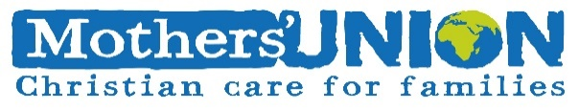

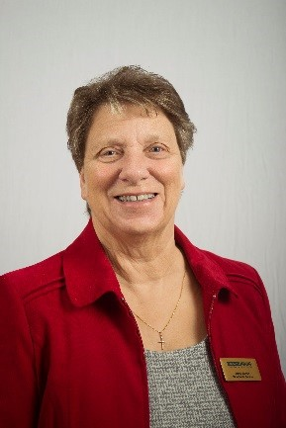**Reflection January 2024**

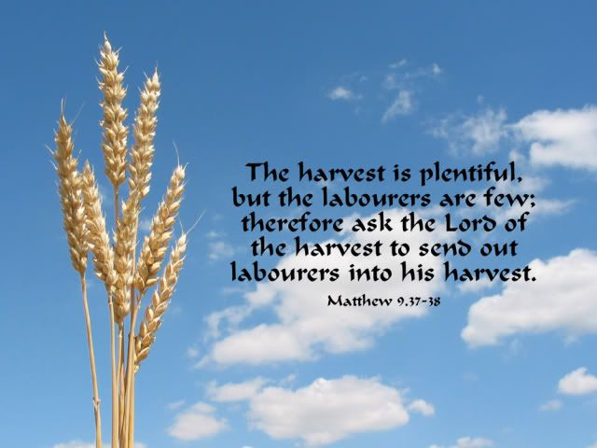My Dear friends, I send greetings as we begin another year, which in His grace, our heavenly Father has given us so we can share His love with others. In Mothers’ Union terms this is a big year, because it is election year, the last year of the triennium, a time of change, a time when we get the opportunity to think about the future of MU. Sometimes we can get too comfortable and set in our ways, and, where new beginnings can be a challenge they are always times to have a positive attitude. As we go through this year let us pray that the right people will come forward to take this wonderful organisation into new growth. There is much work to be done and we need people with the right skills and the given strength to enable us to help even more vulnerable people in the years ahead. In thinking about this I am reminded of the bible passage about the harvest being plentiful but the workers few. We can read this in Matthew 9: 35-38. Here it says, Jesus was visiting towns and villages and preaching in the Synagogues sharing the Good News about the Kingdom and healing. But with a heavy heart, because as he told His disciples, they do not have the correct or enough leaders to bring in the harvest. I am further reminded of the chorus, which I first learnt as a Girl Guide, which is ‘This little light of mine, I’m going to let it shine’ which is about not hiding our ‘light’ or talents, but making sure we use the talents God has given us. So, at the beginning of this year please look around you and speak to members about who in your part of the world may be ready, willing and able to take on roles such as Diocesan President, member of a Trustee board or even Worldwide President. The staff at Mary Sumner House do such a wonderful job working long hours and visiting many of our Dioceses to help and encourage, we need to have the right leaders to support the work they do. Of course, each one of us has our part to play whether we are able to join others at a meeting or we welcome MU friends to the place where we live, we need to start now speaking together and praying that the way forward will be Spirit led and in line with God’s will.

With love & prayers

Jenny

**Let us pray**

A prayer of dedication

Father, at the beginning of this new year, we dedicate ourselves to serve you faithfully and to follow Jesus, to face the future with him, seeking his special purpose for our lives and the lives of all MU members worldwide. Touch the hearts and minds of all whom you are calling to stand as officers for the coming triennium. Enable us to work and witness freely, gratefully and full of hope, in the power of the Holy Spirit and for the honour and glory of your Son, Jesus Christ our Lord. Amen

Mary Sumners Personal Prayer

All this day O Lord, let me touch as many lives as possible for thee, and every life I touch, do thou by thy spirit quicken, whether through the word I speak, the prayer I breathe or the life I live. Amen

A prayer for the week of Christian Unity

*Ephesians 4:13-16*

Lord God, we thank you for calling us into the company of those who trust in Christ and seek to do his will. May your Spirit Guide and strengthen us in mission and service to your world; for we are strangers no longer but pilgrims together on the way to your kingdom. Amen

Prayer of the Inter-Church Process -The Swanwick Declaration

Indoor Members’ Prayer

O God, our heavenly Father, our strength and peace and joy, bless all who are Indoor Members.

Give us your grace according to our need; help us to know and love and trust you more, to pray better and always to do your will, through Jesus Christ, our Lord. Amen

