

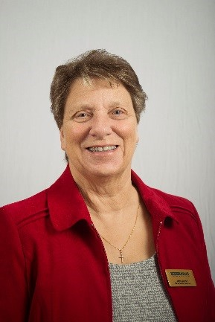**Reflection July 2023**

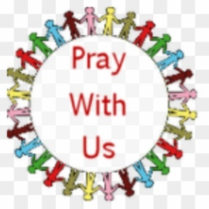My Dear Friends, greetings in the name of our Lord & Saviour, Jesus Christ. I do hope this finds you well and that you managed to keep cool in the long hot summer of June. Hopefully July will give us a bit more of the good British weather we are used to. God our Father built us a wonderful world in which to live, so in our turn we must keep on doing our very best to see that we look after it, so that it is still beautiful for generations to come. I feel sure God would have put prayer at the heart of His creation, in fact the bible tells us ‘God looked at all that he had made and saw that it was good’. As MU members all our work is of course grounded in prayer, and one of the most important members of the Faith team, the Faith Development Adviser, is due to retire at the end of this month. Catherine Kyte has worked tirelessly for the Mothers’ Union for 16 years; I am sure some of you will know her well. During that time, she has not only been responsible for organising many types of training to help with our worship, she has worked with our Chaplains and those responsible for Midday Prayers. She has also provided us with our Wave of Prayer, a wonderful link with all our members worldwide. She has always been available to help individuals and members of staff who perhaps need a little bit of support in a difficult situation, all in all a wonderful Christian soul who will be sadly missed,

but I am sure you would wish Catherine and her husband a long, peaceful and happy retirement. As always, your prayers are needed for the Worldwide President, Sheran, as she continues planning the visits she will make during the rest of this year, and her sharing in the Annual Gathering in York in September. Those of us on the Worldwide Trustee Board also need your prayers as we plan for the next Triennium, voting for which, takes place next year. And of course, all the members of our wonderful staff at Mary Sumner House need prayer, so that they are surrounded with Christ’s love as they continue to work tirelessly with our theme of ‘Transformation---NOW to enable this wonderful organisation to live and grow. Speaking of helping, how did you get on with the challenges I set you last month for the Summer of Hope?

Did any of you manage to make yellow pom-poms to put in your window, or have a collection jar for yours and your visitors loose change? I have managed to make one pom-pom, but three members of my branch managed to complete the 5K sponsored walk raising a generous amount for the Summer of Hope. I have to tell you that they were 76, 79 & 97 respectively so some achievement from a branch of just 8 members.

Please rest assured that you are all always in my thoughts and prayers as are all my family and friends. So now let us pray for one another.

Love & Prayers

Jenny

**Let us Pray**

Father God, we praise you for your creation, may we grow in the Spirit as part of that creation. We join with our family throughout the world, with one voice to glorify your name. Though we may never meet, we are united in prayer. We share our sorrows and joys and together praise our God. As the family of God we are united in love. We glorify our Father with thankful hearts. AMEN

Lord of eternity we pray for the future of Mothers’ Union worldwide. Lead us on to do your will, united in love as disciples of Christ. Guide us in prayer to seek your ways for meaningful growth. Fill us with strength to follow your plans for valuable service. Help us to build a future together which will enable our work to flourish; through far reaching vision and commitment to your will. As we look back with gratitude for the past so we look forward with faith for the future. Together we place our trust in you whose plans stand firm for ever. AMEN

Prayers based on MU Pocket Prayers

We draw all our prayers together in the words that Jesus Taught us,,,,,,, Our Father who art in heaven………….

