Reflection March 2021

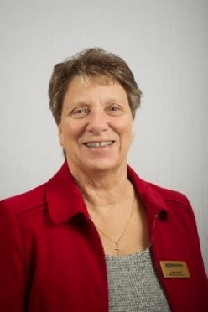
My Dear Friends, Greetings in the name of Jesus, our Saviour. Here we are in March and Spring is just around the corner, even in the middle of Lent there is hope in the air. A time to look forward as we follow our Lord walking with Him through the dark days, travelling towards the light of Easter.

One of the things I really look forward to during Lent is walking the Stations of the Cross. Usually, I do this in my church, this year I have been following from home on YouTube as my Parish Priest leads us once again on that familiar journey. I do hope some of you will have the opportunity to take part in some Lenten activity which is uplifting and leads you into the marvellous light which will shine on Easter Day.

After such a wet and cold winter, I am looking forward to being able to spend time once again in my garden, I love the feel of the soil on my hands and the warmth of the sun on my back, as I plant seeds which will grow and become food which I can not only enjoy eating but sharing with family and friends. Family is the most precious thing we have in life, whether that be siblings, children & grandchildren or the family of the church and Mothers’ Union.

During March we celebrate Mothering Sunday and this year we are asked to give ‘Gifts of Togetherness’. This is such a good way for us to give thanks for our Mothers by enabling families from around the world to grow in confidence. If you are able please consider a gift from those shown in the Mothering Sunday booklet, gifts start at just £7, and I know they will make a difference to people’s lives.

We have spent so much time apart from our families but I pray that we will soon be able to once again share in that special kind of love that only being with those we care about brings. So, I wish you all a blessed Lent, Holy Week and the joy of the Easter celebration.

Love & Prayers
Jenny

Let us pray

From Prayers we breathe: -
Father, we thank you that you have created us into families, so that we my live, play, work, rejoice and grieve together.
Above all, we thank you that we are able to be members of your family and mothers in your church.
We thank you for our Christian family throughout the world.
We pray that our hearts may be united in prayer so that we are able to share one another’s burdens, rejoice in one another’s blessings and strengthen one another in the power of your Holy Spirit. Amen.

Doris Decker, Ghana

Ephesians 3: 14- 19
For this reason I kneel before the Father, from whom his whole family in heaven and on earth derives its name. I pray that out of his glorious riches he may strengthen you with power through his Spirit in your inner being, so that Christ may dwell in your hearts through faith. And I pray that you, being rooted and established in love, may have power, together with all the saints, to grasp how wide and long and high and deep is the love of Christ, and to know this love that surpasses knowledge-that you may be filled to the measure of all the fulness of God.

We are the family of God, purchased by His precious blood

