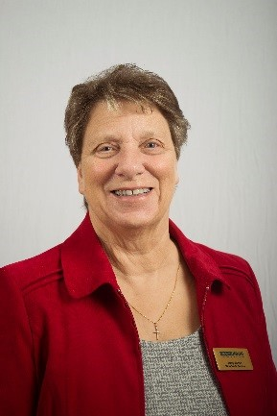
Reflection March 2022
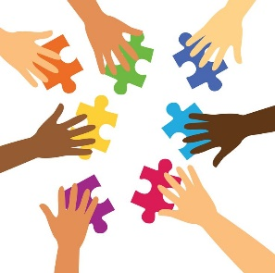
My Dear Friends, how good it is to see signs of A new season. As I look out at my garden, I can see daffodils, crocuses and honeysuckle either flowering or coming into bud in the borders, and even daisies popping up through the grass and day by day my garden is changing, being ‘transformed’ created into new life. I hope you too are beginning to feel a new spring in your step and a warmth in your heart. All this transformation is a gift given to us by God. It is good to remember that we are all part of God’s creation, a piece of the jigsaw puzzle of life. When I look at the pieces of a jigsaw puzzle, I see lots of different shapes and sizes, which at first seem like a jumble of pieces which can in no way make a sensible picture. But as I begin to place one piece and then another into the slot which is just the right fit, I see a picture immerge which transforms what was just a jumble of pieces into something rather wonderful, the jigsaw of life is rather wonderful. It has its up and downs, bumps in the road, which have to be negotiated, friendships which have to be built on strong foundations. Family relationships which can be challenging but, where love is then whatever shape the challenge takes this can be overcome. All these things transform us. I was watching some of the Winter Olympics recently, perhaps you watched them too. I was watching the curling and skying; I have never tried curling but I did try skying when I was a few years younger. As I watched it reminded me that however hard the challenge the athletes never gave up, they always had their eye on the prize because to give up was to admit failure and defeat.
Over the last two years it seems we have all been biding our time, waiting, hibernating, and many of us have been shielding. But now is the time for us to re-emerge, to take our place in the world as best we are able. A new season is a good time for new beginnings for transforming ourselves into something new.
Over the last two years the Mothers’ Union has been transforming also and as you are aware the MU theme for this year is ‘Transformation –NOW’. A lot of transformation has been taking place beginning with staffing levels at MSH. Because of Covid changes had to be made, the result being fewer staff to carry out the same amount of work. At Diocesan and Branch level too numbers are down, which means changes are having to be made which is affecting the way we are able to function. All of this requires prayer, something I know you are all good at. This is needed now more than ever and I ask. Are you just the person to stand beside me as I pray? Are you just the right shape piece to fill the gap in the jigsaw? I hope so because together we are stronger and will be able to help build a complete picture which will ‘Transform’ and help grow the wonderful organization which Mary Sumner fought so hard establish.

Love & Prayers
Jenny

From Romans 12:2
Do not conform to the pattern of this world, but be transformed by the renewing of your mind.
Then you will be able to test and approve what God’s will is-----His good pleasing and perfect will.

Let us pray
Father, as we welcome a new season may it be a new beginning for us. May we be blessed and feel part of the jigsaw of life. We pray for the Mothers’ Union, of which we are part, asking that you will continue to transform it. Empower and encourage us to go for growth.
We ask that you will give strength to those who lead, praying particularly for the Senior Leadership Team and the members of their departments as they continue to take on extra responsibility. We pray that it will be possible to increase their number in the near future. We pray also for our Worldwide President Sheran and the members of the Trustee Board as they stand alongside one another to support the work Mary Sumner started. Help us all, as we walk in your love along our own Emmaus Road, to recognise our Lord and Saviour, Jesus Christ, in whose name we pray. AMEN
Let us pray The Lord’s Prayer together
Our Father------

Transformation----- NOW Transformation----NOW

