Reflection May 2021
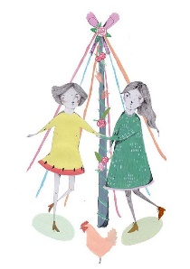
My Dear Friends, I have been considering a lot of things since I last wrote in March. April contained so many different occasions, some happy like Easter and the opening up of more of the UK to enable us to begin to come together more freely once again. Some sad like the death of The Duke of Edinburgh and my friend of 60 years, both will be sorely missed by those who held them dear.
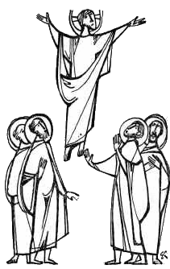
But now as we enter May we have other things to occupy our thoughts. 1st of May, now known as May Day, used to be called Labour Day, I am sure some people may still think of it that way. Before I moved to Wales the village where I went to church used to hold a big medieval festival on the 1st May, with many stalls and side shows, including children from the local school entertaining us with maypole dancing, a great way of bringing the community together. On 13th we will hopefully all be able to join with other members of our church family for Ascension Day. Then on the 23rd May we celebrate Pentecost, the coming of the Holy Spirit which filled the lives of the disciples enabling them to tell of God’s love. I pray that we too may so be filled so that we are able to follow their example, speaking freely to those we meet on our journey of faith.
At the end of the month, we have Spring Bank Holiday, when once more our children and grandchildren will be away from school and this year, we may be able to get together outside to share fellowship.

We need to give thanks for the drop in the number of cases of Covid in the UK, however in other parts of the world this is not the case and many are still seriously ill or dying, so we may wish to spend some time thinking about our members in these countries as we celebrate the changes in our own.

But for us in MU May has brought us a new way to keep in touch, our new member magazine ‘Connected’ what an interesting and informative read it is, bringing us stories of Mothers’ Union around the world making a difference in these difficult times. On page 23 we are reminded that, ”Mothers’ Union cannot afford to stand still”, how true that is and I am sure that all of us would agree, we are a progressive organisation, following in Mary Sumner’s footsteps. Remember how progressive she was when back in the mid 1800s she brought together people from different walks of life to work for a common cause, bringing more and more hope and confidence to those she set out to serve.

One thing I really like about May are the lighter nights, I find it hard to cope with dark mornings and closing the curtains at 4pm in the afternoon. Now, with the warmer weather coming and the days lengthening we can all be out in our gardens or the local park or sitting on a balcony enjoying God’s creation. But don’t forget to keep creating those much needed items for our hospitals, care homes and prisons. If you are not able to share in the knitting and sewing then please don’t forget to do the most important thing of all, PRAY, prayer is, and always has been what underpins all our work as MU members “Sometimes praying can be really hard, but God appreciates all our efforts”, says Catherine Kyte, Faith Development adviser at MSH. You will find lots of ideas to help you with prayer on the MU website. If you don’t have access to the website there will be someone you know who will, so please ask for help.
Love & Prayers
Jenny

So, as we look back and give thanks to our risen Lord for all His care, let us look forward and ask for His continued guidance using the prayer given to us from our worldwide President, Sheran Harper.

A prayer for rebuilding hope and confidence
We will walk in hope and confidence, trusting each other, loving each other - and together we will rebuild the hope and confidence of families and communities everywhere - always reaching forward as God’s hands and feet and reflecting a life filled with purpose and meaning, grace and love, peace and joy. AMEN

Let us share together in the words Jesus himself taught us, saying in the style and language that is best for you. OUR FATHER ………

