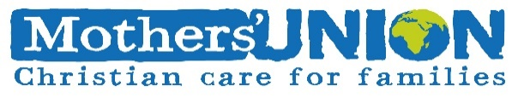
Reflection October 2023

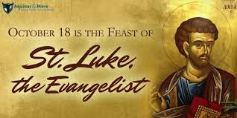
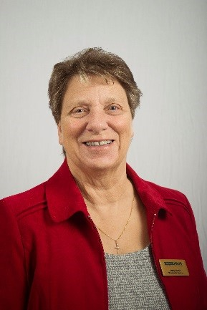
My Dear Friends, greetings in the name of our Lord and Saviour, Jesus Christ. Here we are in the month of October, a month when in the week which includes the18th we celebrate St Lukes tide. A time when we give thanks for St Luke, the writer of the Gospel of the same name, who it is thought also wrote the Acts of the Apostles. At the heart of Lukes Gospel is an incredibly generous welcome of people. It’s an engaging message of God’s grace offered to all. We are also called to live out this welcome in our everyday lives, as a church, in the place where we live and as MU members. In many rural communities in northern Britain, St Luke’s tide coincided with harvesting the potato crop and the half term school holidays were fixed so that children could help with ‘potato picking’. Often a fair would visit a nearby town to provide some relaxation and amusement. If the weather was good, the people looked forward to what was known as ‘St Lukes little summer’ St Luke was a man for the people and there is a prominent place for women in his Gospel. As a member led organisation, which worldwide consists mainly of women, St Luke is a good rule model for us as MU members to follow. He allows us to be strong and stand up for those whose lives are challenged by men who want to rule them. This is particularly the case in some of the developing countries. When I visited Uganda with the Mothers’ Union a few years ago I listened as MU members there told how men got drunk from the beer, which was being made by the women to raise money to feed their families, then went home and beat their wives.
As anyone who was being beaten would, the women cried out at this behaviour, but found that if they placed a small stick in their mouth which they could bite down on it helped them keep quiet, which in turn helped both them and their men to calm down and the beating stopped much sooner. Since then, the MU has been working hard to educate both the men and the women. They have found other ways for the women to raise the much needed money and taught the men that their behaviour had to change, making for much stronger family relationships. St Luke was a writer and the MU’s literacy programme is also helping with adult education which in its turn enables people to have more confidence and an ability to understand and see the world around them in a different way. Part of the work I do with members from my church is to go into my local schools and listen to children read, some of these children just need a little bit of help with something which can be very daunting. Each of us find things in life daunting at times, perhaps there is something in your life you would love to have help with particularly as you get older, I know this is true for me. But don’t let us forget that there is help out there. As women we are strong but we can be stubborn and think we can manage. As men we can think it is beneath us to ask for help, especially from a woman. Jesus taught us to love one another and to help one another and the Gospels tell many stories of Jesus helping people, but Luke is the only one who tells us the story of the Good Samaritan and The Prodigal Son, both stories of healing and reconciliation. Part of the work the MU does is help those whose family life has met with adversity, this can take many forms and includes the work we do in the UK and Ireland to help those in prison, hospital or find themselves a refugee.

Please pray that this work will flourish and grow strong, and please pray for Sheran, the Worldwide President and the members of the Worldwide Trustee board, who work closely with our CEO Bev and all who work at Mary Sumner House to help us be aware of those around us and encourage us follow in the steps of Mary Sumner. When St Luke’s Day comes on the 18th of this month let us celebrate and give thanks that we are part of the healing work this world so badly needs, so go forward in His name and be strong in faith and in life.
Love & Prayers
Jenny

Let us Pray

Father God, you chose Luke to reveal your wonderful love for the poor, the sick and the broken. Grant that all of us who acknowledge your name may join together to work for the healing and equality of all human beings and the reconciliation of all the nations. shed the light and warmth of your love in our world through us all; in the name of Christ. AMEN

Indoor members prayer
Loving, heavenly Father, Lord of all the world, you know the secret thoughts of every heart and hear the prayers of all. You have chosen us to work for you and be as one in prayer. Guide us in our prayerful task, and strengthen us to do your will. Uphold us in our weakness and our doubt that those for whom we intercede may truly come to know your healing peace and love. We ask in Jesus’ name your only Son, our Lord AMEN
The Lord’s Prayer

