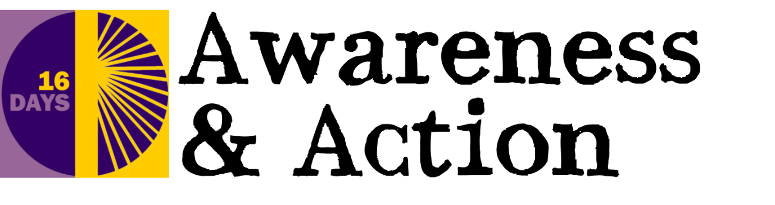

Support Available to Survivors of Gender-Based Violence
Forced Marriage Unit Helpline: 0207 008 0151

Honour Network Helpline: 0800 599 9247 www.karmanirvana.org.uk

National Domestic violence Helpline: 0800 200 0247 www.nationaldomesticviolencehelpline.org.uk

Refuge: 0808 200 0247 www.refuge.org

Women’s Aid: 0808 200 0247 www.womensaid.org.uk

Rights of Women: 020 7251 887 www.rightsofwomen.org.uk

FLOWS (Finding Legal Options for Women Survivors): 0203 745 7707 www.rcjadvice.org.uk/family/flows-finding-legal-options-for-women-survivors/

Men’s Advice Line: 0800 801 0237 www.mensadviceline.org.uk

Mankind Initiative: 01823 334 244 www.mankind.org.uk

M-Power: 0808 808 4321 www.male-rape.org.uk

National Centre for Domestic Violence: 0800 970 2070 www.ncdv.org.uk

Samaritans: 08457 90 90 90 www.samaritans.org

Rape Crisis England and Wales Freephone Helpline: 0808 802 9999 www.rapecrisis.org.uk

Victim Support: 0845 30 30 900 www.victimsupport.org.uk

The Survivors Trust: 01788 550 554 www.thesurvivorstrust.org

National LGBT Domestic Violence Helpline: 0300 999 5428 www.brokenrainbow.org.uk

Respect Phoneline: 0808 802 4040 www.respectphoneline.org.uk

Montgomeryshire Family Crisis Centre Helpline: 01686 629 114 www.familycrisis.co.uk

Republic of Ireland:

Amen: (for men) 01-5543811 www.amen.ie

Crime Victim Helpline: 116 006 www.crimevictimshelpline.ie

Samaritans: 116 123 www.samaritans.org.uk

Sonas: 01 866 2015 http://www.domesticabuse.ie/

