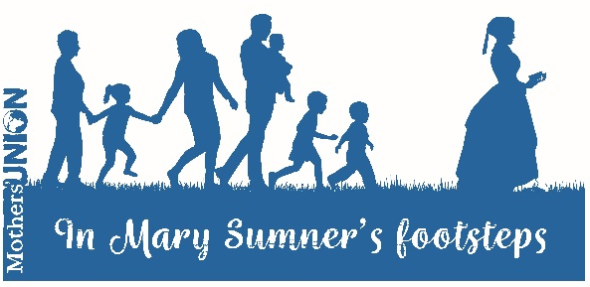

In Mary Sumner’s footsteps:
Taking steps of faith

A Reflective Prayer activity on taking steps of faith

This resource may be used as the basis for a Quiet Day, a shorter prayer activity or as separate reflections. You may find it helpful to link the prayers with considerations as to the way ahead for Mothers’ Union in your own area as well as with specific local, national or global Mothers’ Union projects and initiatives.

In Mary Sumner’s footsteps:

Taking steps of faith

Steps of faith

What does the Lord require of you?
To act justly and to love mercy
and to walk humbly with your God.
Micah 6:8

We set our feet
once again
on the way walked by Jesus.

These steps of peace may be difficult
in a terrain that slopes toward violence.

These steps of justice may prove tiring
as we walk against the winds of injustice.

These steps of love may be painful
with so much hatred to step over and bump up against.

Give us the wisdom
Give us the strength
to take these steps anyway.

Each day a new step.
Each step a faithful movement toward your kingdom.

Each step taken only by your grace
only in your power
our Creator, Redeemer, Sustainer. Amen
Joanna Harader, http://spaciousfaith.com

Mustard seed faith

Jesus said:
If you have faith as small as a mustard seed,
you can say to this mountain,
“Move from here to there,” and it will move.
Nothing will be impossible for you.
Matthew 17:20

God of miracles
bless our tiny steps of faith
that mountains may be moved.

Almighty and loving God,
take our faith, weak though it is.
Kindle the sparks of life within us
and fan a new flame within our hearts.

And so may we set out with renewed purpose,
resolved to live and work for you,
in the assurance that you are with us,
now and always.
Nick Fawcett Prayers for all Seasons; 1998

God of miracles
take our tiny steps of faith
and use them to bless your world. Amen

Walking with Christ

We are his workmanship, created in Christ Jesus for good works,
which God prepared beforehand, that we should walk in them.
Ephesians 2:10 (ESV)

Heavenly Father,
fill us with vision and purpose
as we step forward with Christ in faith.

We thank you for creating us in Christ
to live out your purposes,
which you have so lovingly prepared.

We thank you for uniting us with Christ
to carry out your plans
which you have made ready for us.

We thank you that walking with Christ
empowers us for the life of service
for which we are created.

Heavenly Father,
fill us with hope and joy
as we step forward with Christ in faith. Amen

Stepping out together

The Lord appointed seventy-two others and sent them two by two ahead of him to every town and place where he was about to go. He told them, “The harvest is plentiful, but the workers are few. Ask the Lord of the harvest, therefore, to send out workers into his harvest field.”
Luke 10:1-2

Gracious Lord,
send us out together with Christ,
as partners in service and purpose.

Lord of the harvest, we praise you
for those who work alongside us;
sharing tasks and sharing vision.

We thank you for each other;
our partners in service and purpose.

Lord of the harvest, we praise you
for those who walk alongside us;
pressing onwards for mutual goals.

We thank you for each other;
our partners in service and purpose. Amen

Walking on water

“Lord, if it’s you,” Peter said, “tell me to come to you on the water.”
“Come,” he said.
Then Peter got down out of the boat, walked on the water and came towards Jesus.
Matthew 14:28-29

Jesus calls us to step out on to the water with him,
to leave the safety of our boats,
and to walk toward Him in faith,
joining Him in the work
He is already doing in our world.

And when the wind and waves get high
and threaten to overwhelm us,
we remember His words:
“Don’t be afraid. Take courage. I am here.”
https://re-worship.blogspot.co.uk

Loving Lord,
fill us with courage
to step out of our comfort
and forward in faith;
trusting in your presence
through all that lies ahead. Amen

Running with faith

Let us run with perseverance the race marked out for us,
fixing our eyes on Jesus, the pioneer and perfecter of faith.
Hebrews 12:1-2

We follow in your footsteps Lord;
running after you for the joy of the race
and the prize that lies ahead.

I will not stumble
for your hand will guide
and in your footsteps I will tread.

I will not grow weary
for your spirit sustains
and my soul shall be renewed.

I will not be weak
for your truth strengthens
and no evil shall defeat me.

From the depths of the earth
I shall soar upward
on wings like eagles,
spread the news
throughout the world,
run the race
against all odds,
and shall prevail.
John Birch www.faithandworship.com

We follow in your footsteps Lord;
fixing our eyes on Christ,
trusting in you to lead us home. Amen

Final Blessing

We step out into the world with faith,
to follow where Christ leads,
trusting in his presence
for all that lies ahead. Amen

