Knitted Teddy Hand Puppet Pattern

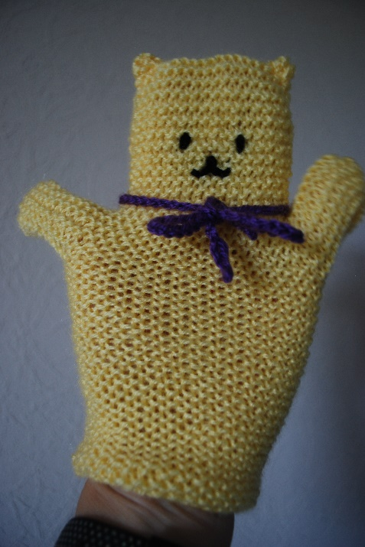
Materials
Washable double knitting yarn in main colour
Contrasting double knitting yarn for the scarf and for stitching features

Please avoid ‘tinsel’ yarns, those with attached sequins or mohair style yarns with fibres that pull off.

4mm knitting needles (UK size 8)

Tension
12st and 24 rows to 5cm over garter stitch on 4mm needles

Instructions
Work in garter stitch (Knit all rows) throughout.

Cast on 18 stitches (sts) and knit for 10cm (4 inches).
Next row
Cast on 10 sts and knit to the end (28 sts).
Next row
Cast on 10 sts and knit to the end (38 sts).
Continue knitting on 38 sts for 2.5cm (1 inch).
Next row
Cast off (loosely) 10 sts and knit to the end (28 sts)
Next row
Cast off (loosely) 10 sts and knit to the end (18 sts).
Continue knitting on 18 sts for 6.5 cm (2½ inches).
Cast off loosely, leaving about 45cm (18 inches) of yarn for sewing up.

Knit another piece the same.

To make up:
On one of the pieces, using contrasting yarn, stitch eyes, a nose and a ‘smile’.
Stitch the two pieces together and make two ears by ‘pinching in’ the two top corners.

Make a scarf from a crochet chain (or plaited wool) of 45 cm (18 inches). Secure firmly across the back of the teddy puppet to keep in place. The loose ends of the scarf must not exceed 22cm (8½ inches).

