Thy Kingdom Come: ABC of prayer for MU@home

Although it’s good to pray with others during Thy Kingdom Come, there may be times when we become MU@home, either for short term, specific reasons, or as indoor members.

This template helps us to pray with purpose personally during Thy Kingdom Come; both for friends and family to experience the love and good news of Christ, and for the various ways Mothers’ Union shows Christ’s love as we put our faith into action.

You’ll find more ideas in the Praying with Purpose resource. https://www.mothersunion.org/praying-with-purpose

A Begin by offering your praise and thanks for friends and family, for local community initiatives and answered prayer so far. Remind yourself of the power of prayer and God’s willingness to answer by reflecting on appropriate Bible verses

Loving Lord, thank you for the privilege of being involved in the work of building the Kingdom of God on earth through my prayers for (mention specific names and church and community initiatives etc.)
I praise you with thankful heart for your answers to prayers thus far, in particular (mention specific answers) Truly you are an awesome God!

Thank you for your presence with me as I bring my requests
and petitions.
Thank you for the help of the Holy Spirit in putting needs into words, and in pleading their case before you.
I commit my time to you, for the growth of your Kingdom
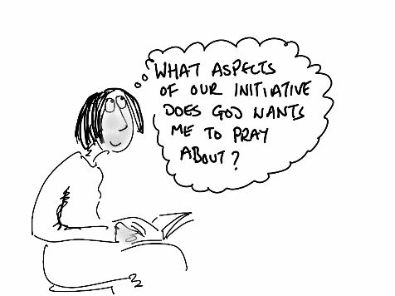
and the glory of Christ. Amen

B Now move into praying for specific people and initiatives:

- As well as bringing before God your prayer points you may like to choose appropriate passage of scripture, reflect on it for a few minutes then use the thoughts God highlights to you to pray.

- If you enjoy craft activities you could also engage in them as another way to pray – especially if the project includes craft in some way e.g. knitting – pause after every row to pray; focus on those who will benefit from the knitted item and use your thoughts as a basis for prayer

Write down any particular themes that emerge as you pray
and use them as further encouragement to keep praying.

C Finish by using a Biblical blessing to ask God to bless the people and initiatives

for which you have been praying

