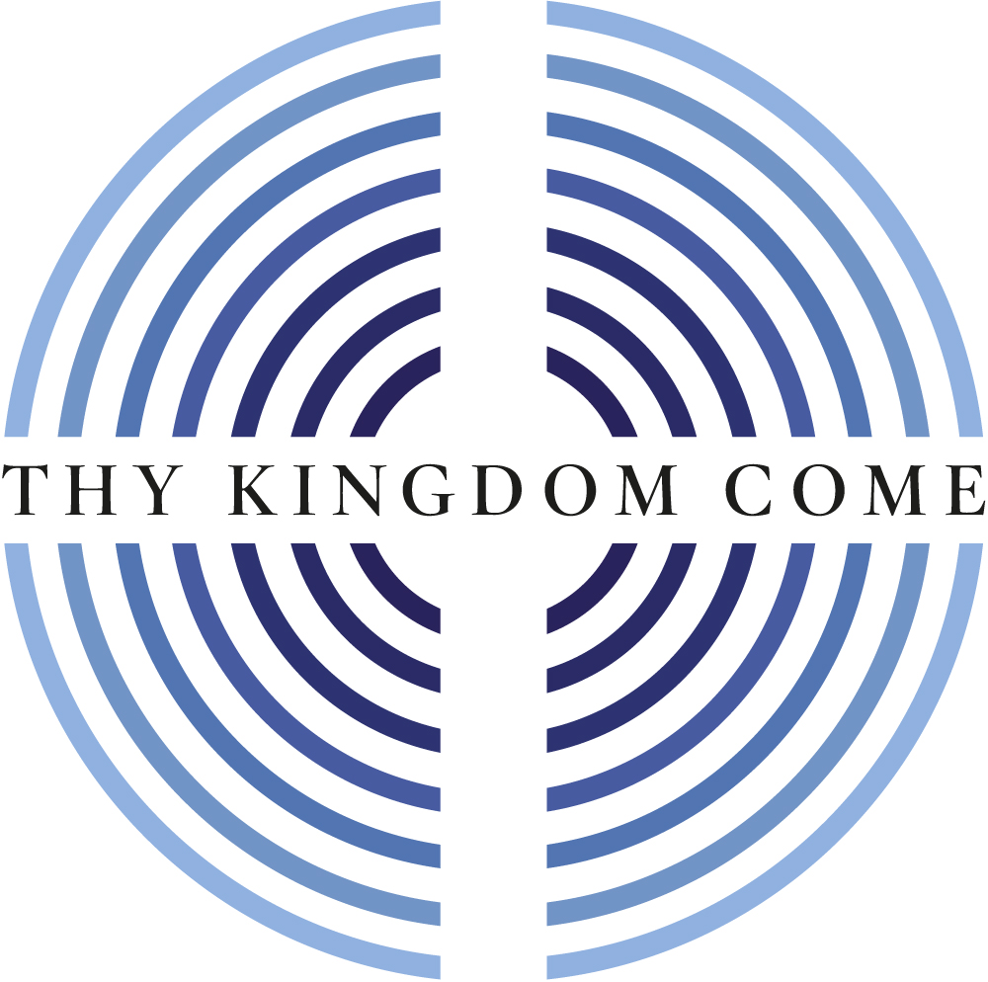

Midday Prayers 2021: Rebuilding hope and confidence

13th – 23rd May

Thy Kingdom Come

In praying 'Thy Kingdom Come' we all commit to playing our part in the renewal of the nations and the transformation of communities.

Archbishop Justin Welby

As part of Mothers’ Union’s engagement with the global prayer movement Thy Kingdom Come we have produced special Midday Prayers for its duration using material from the Thy Kingdom Come resources, in particular, the 2021 Prayer Journal.

Thursday 13th May

Almighty God,
your ascended Son has sent us into the world
to preach the good news of your kingdom:
inspire us with your Spirit and fill our hearts
with the fire of your love,
that all who hear your word may be drawn to you,
through Jesus Christ our Lord. Amen

Glory to God,
whose power, at work among us,
can do infinitely more
than we can ask or conceive;
to him be glory in the Church
and in Christ Jesus,
for ever and ever.
Alleluia. Amen

Wave of Prayer for Mothers’ Union

Lord, we pray for the witness and work of Mothers’ Union worldwide.
Today we pray for our members in:
Twic East in South Sudan; Rorya in Tanzania; Owerri & Ughelli in
Nigeria; Gippsland in Australia and Cashel & Ossory in All Ireland

Final blessing

We go with faith in Christ
who taught us to pray thy Kingdom come;
to witness of his love throughout the world. Amen

Friday 14th May

Come, Holy Spirit, fill the hearts of your people
and kindle in us the fire of your love.

Thomas said to him: Lord, we don’t know where you are going,
so how can we know the way?
Jesus answered: I am the way and the truth and the life.
No one comes to the Father except through me.
John 14: 5-6

Loving God,
when I’m feeling lost or lonely
or afraid or uncertain of the way ahead,
be my guide, a lamp to my feet
and a light for my path.
And today help me to be
a good companion to those I meet.

God of our salvation,
hope of all the ends of the earth,
we pray: Thy kingdom come.
Amen

Wave of Prayer for Mothers’ Union

Lord, we pray for the witness and work of Mothers’ Union worldwide.
Today we pray for our members in:
Maridi in South Sudan; Kirinyaga in Kenya; Zaki-Biam & Ijesa North-East
in Nigeria and Waikato & Taranaki in New Zealand

Final blessing

We go with faith in Christ
who taught us to pray thy Kingdom come;
to witness of his love throughout the world. Amen

Saturday 15th May

Come, Holy Spirit, fill the hearts of your people
and kindle in us the fire of your love.

Why, my soul, are you downcast?
Why so disturbed within me?
Put your hope in God,
for I will yet praise him,
my Saviour and my God.
Psalm 42:11

Faithful God, help me to understand myself,
so that even in the most difficult times
I may know your presence with me
and may sing your praises, defiantly praising your goodness
even when there is so much that is wrong.
And today, help me show others the good things
I receive in Christ and show the world His way.

God of our salvation,
hope of all the ends of the earth,
we pray: Thy kingdom come.
Amen

Wave of Prayer for Mothers’ Union

Lord, we pray for the witness and work of Mothers’ Union worldwide.
Today we pray for our members in:
Maridi in South Sudan; Kirinyaga in Kenya; Zaki-Biam & Ijesa North-East
in Nigeria and Waikato & Taranaki in New Zealand

Final blessing

We go with faith in Christ
who taught us to pray thy Kingdom come;
to witness of his love throughout the world. Amen

Sunday 16th May

Come, Holy Spirit, fill the hearts of your people
and kindle in us the fire of your love.

Jesus said: The Advocate, the Holy Spirit,
whom the Father will send in my name, will teach you all things
and will remind you of everything I have said to you.
John 14:25-26

Overcoming God,
make me new in the Spirit of Jesus
so that I can truly become the person I am meant to be.
And today may your Spirit help me help others,
especially those who have drifted from your way,
or who find it impossible to believe,
or who are trapped by fear and guilt.
Set me free, God. Set me free to be myself.
Free to help others.

God of our salvation,
hope of all the ends of the earth,
we pray: Thy kingdom come.
Amen

Wave of Prayer for Mothers’ Union

Lord, we pray for the witness and work of Mothers’ Union worldwide.
Maridi in South Sudan; Kirinyaga in Kenya; Zaki-Biam & Ijesa North-East
in Nigeria and Waikato & Taranaki in New Zealand

Final blessing

We go with faith in Christ
who taught us to pray thy Kingdom come;
to witness of his love throughout the world. Amen

Monday 17th May

Come, Holy Spirit, fill the hearts of your people
and kindle in us the fire of your love.

Let the peace of Christ rule in your hearts,
since as members of one body you were called to peace.
And be thankful.
Colossians 3:15

Generous God,
fill my heart with thanksgiving
for all the blessing I receive in life.
Expand my heart, and help me love,
support and cherish those who serve me.
And today help me to live as sister or brother
to all whom I meet.

God of our salvation,
hope of all the ends of the earth,
we pray: Thy kingdom come.
Amen

Wave of Prayer for Mothers’ Union

Lord, we pray for the witness and work of Mothers’ Union worldwide.
Today we pray for all of our members throughout the world
and for the work that they do in the name of Christ

Final blessing

We go with faith in Christ
who taught us to pray thy Kingdom come;
to witness of his love throughout the world. Amen

Tuesday 18th May

Come, Holy Spirit, fill the hearts of your people
and kindle in us the fire of your love.

I urge, then, first of all,
that petitions, prayers, intercession
and thanksgiving be made for all people.
1 Timothy 2:1

Transforming God,
make me more like Jesus.
And because I know my life is not like that,
show me Jesus today.
Change my prayer from asking things for myself
to asking you what you would like for me,
so that my life can be part of your story.
And help me to pray for others,
that they may know Christ for themselves.

God of our salvation,
hope of all the ends of the earth,
we pray: Thy kingdom come.
Amen

Wave of Prayer for Mothers’ Union

Lord, we pray for the witness and work of Mothers’ Union worldwide.
Today we pray for our members in:
Grahamstown in South Africa; Masasi in Tanzania; Afikpo in Nigeria;
Wiawso in Ghana; Chester in England and Northern Argentina in Argentina

Final blessing

We go with faith in Christ
who taught us to pray thy Kingdom come;
to witness of his love throughout the world. Amen

Wednesday 19th May

Come, Holy Spirit, fill the hearts of your people
and kindle in us the fire of your love.

Jesus said: love each other as I have loved you.
Greater love has no one than this:
to lay down one’s life for one’s friends.
You are my friends if you do what I command.
John 15:12-14

Quickening God, fan the embers of my little faith.
Help me see that the love I feel for those I love is from you.
It shows me that you are real, that you are love itself.
Be my friend.
And today, draw me back into the fellowship of your church
and help others, who also long for love and acceptance,
to find it in Jesus, the one who lays down his life for his friends.

God of our salvation,
hope of all the ends of the earth,
we pray: Thy kingdom come.
Amen

Wave of Prayer for Mothers’ Union

Lord, we pray for the witness and work of Mothers’ Union worldwide.
Today we pray for our members in:
Grahamstown in South Africa; Masasi in Tanzania; Afikpo in Nigeria;
Wiawso in Ghana; Chester in England and Northern Argentina in Argentina

Final blessing

We go with faith in Christ
who taught us to pray thy Kingdom come;
to witness of his love throughout the world. Amen

Thursday 20th May

Come, Holy Spirit, fill the hearts of your people
and kindle in us the fire of your love.

Is not the cup of thanksgiving for which we give thanks
a participation in the blood of Christ? And is not the bread
that we break a participation in the body of Christ?
Because there is one loaf, we, who are many, are one body,
for we all share the one loaf.
1 Corinthians 10:16-17

Bountiful God,
feed me with the bread of heaven,
give me today the things I need for today
and save me from wanting more than my share.
There are so many people who are hungry for love
and thirsting for peace.
Help me to help others find their place at your table.

God of our salvation,
hope of all the ends of the earth,
we pray: Thy kingdom come.
Amen

Wave of Prayer for Mothers’ Union

Lord, we pray for the witness and work of Mothers’ Union worldwide.
Today we pray for our members in:
Grahamstown in South Africa; Masasi in Tanzania; Afikpo in Nigeria;
Wiawso in Ghana; Chester in England and Northern Argentina in Argentina

Final blessing

We go with faith in Christ
who taught us to pray thy Kingdom come;
to witness of his love throughout the world. Amen

Friday 21st May

Come, Holy Spirit, fill the hearts of your people
and kindle in us the fire of your love

This is love: not that we loved God, but that he loved us
and sent his Son as an atoning sacrifice for our sins.
Dear friends, since God so loved us,
we also ought to love one another.
1 John 4:10-11

Loving God,
our hearts are restless till they find their rest in you.
Be my rest and my security, for the storms are raging
and the waves crash over.
Help me to know today that all that is good comes from you
and will return to you in the silence
of your eternal and never changing love.
Be with me as I hold myself and hold others
in your loving embrace.

God of our salvation,
hope of all the ends of the earth,
we pray: Thy kingdom come.
Amen

Wave of Prayer for Mothers’ Union

Lord, we pray for the witness and work of Mothers’ Union worldwide.
Today we pray for our members in:
Christ the King in South Africa; East Rwenzori in Uganda;
Gombe & New Busa in Nigeria and Bunbury in Australia

Final blessing

We go with faith in Christ
who taught us to pray thy Kingdom come;
to witness of his love throughout the world. Amen

Saturday 22nd May

Come, Holy Spirit, fill the hearts of your people
and kindle in us the fire of your love

Since we have been justified through faith, we have peace with God through our Lord Jesus Christ, through whom we have gained access by faith into this grace in which we now stand. We boast in the hope of the glory of God. And hope does not put us to shame, because God’s love has been poured out into our hearts through the Holy Spirit, who has been given to us.
Romans 5:1-2, 5

Overflowing God,
breathe the spirit of Jesus into me
and into all those who long for peace,
especially those who have drifted from your way,
got stuck in their faith, or who have not yet found a way to believe.
You believe in them. Renew them by your Spirit.
And today may your Church be filled with joy

God of our salvation,
hope of all the ends of the earth,
we pray: Thy kingdom come.
Amen

Wave of Prayer for Mothers’ Union

Lord, we pray for the witness and work of Mothers’ Union worldwide.
Today we pray for our members in:
Christ the King in South Africa; East Rwenzori in Uganda;
Gombe & New Busa in Nigeria and Bunbury in Australia

Final blessing

We go with faith in Christ
who taught us to pray thy Kingdom come;
to witness of his love throughout the world. Amen

Sunday 23rd May

Almighty God,
your ascended Son has sent us into the world
to preach the good news of your kingdom:
inspire us with your Spirit and fill our hearts
with the fire of your love,
that all who hear your word may be drawn to you,
through Jesus Christ our Lord. Amen

Glory to God,
whose power, at work among us,
can do infinitely more
than we can ask or conceive;
to him be glory in the Church
and in Christ Jesus,
for ever and ever.
Alleluia. Amen

Wave of Prayer for Mothers’ Union

Lord, we pray for the witness and work of Mothers’ Union worldwide.
Today we pray for our members in:
Christ the King in South Africa; East Rwenzori in Uganda;
Gombe & New Busa in Nigeria and Bunbury in Australia

Final blessing

We go with faith in Christ
who taught us to pray thy Kingdom come;
to witness of his love throughout the world. Amen

