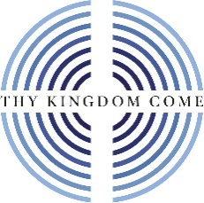
Thy Kingdom Come 2023

Ideas for local engagement

- On the Thy Kingdom Come website you will find a link featuring a past MU service in Coventry Cathedral. Day 7: Thy Kingdom Come: A Wave of Prayer Across the Nations - Mothers’ Union (Coventry Cathedral) on Vimeo
Why not show this as an introduction and inspiration for your MU involvement in this year’s Thy Kingdom Come? Invite other church members and other churches to be part of this initial gathering and share together ways to partner in supporting it.

- Arrange a prayer walk round your local community with other members of your church and other local churches. Finish with refreshments and time of prayer for the local area. (You could also use ideas in Metamorphosis Bitesize to explore together the needs of the local area - e.g. the community mapping tool)

- Ask if Mothers’ Union can lead Sunday intercessions in your church during Thy Kingdom Come. You could use our MU Thy Kingdom Come Midday Prayers or prayers from the 2023 Prayer Diary.

- In partnership with others, arrange an event to benefit the community: Fun Day; community picnic; community clean up...

- Set up prayer stations in your church representing the needs of the local community. Use creative ideas for prayer e.g. paper chains of prayer – add a link with the name of someone/some situation that needs prayer and then display as a reminder to pray.

- Explore the possibility of having a display of Mothers’ Union initiatives in a local library or community hall. Include information about how to become part of Mothers’ Union

You will also find more ideas and resources on the Thy Kingdom Come website https://www.thykingdomcome.global/

